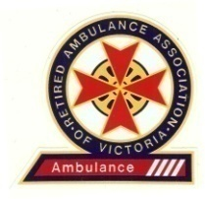
All Correspondence to:
The Secretary
Unit 2 / 20 Brooks Street
Bentleigh East
Victoria 3165
Mobile: 0435 010 943
Email: raav.secretary@gmail.com

Retired Ambulance Association
of Victoria Incorporated
ABN: 77 829 511 359
Registered Number: A0021423S

Bullying and Harassment Statement

The Retired Ambulance Association of Victoria (RAAV) is totally committed to maintaining an inclusive, heathy and safe operating environment for its members. RAAV will not condone any form of bullying or harassment in the workplace, or within its Association.

The RAAV Bullying and Harassment Policy (Policy) mandates the expected standards and behaviour applicable to its members. RAAV values its members and their previous contribution to the community and is confident its members share the position outlined above. However, anyone found to have breached the Policy will be subject to formal action, which may include a termination of membership.

RAAV encourages its members to openly discuss this important subject and proactively maintain an inclusive, heathy and safe operating environment that we all enjoy.

Mike Williams MEd.(Melb.), FACPara
Vice President RAAV
Mobile 0403 156 313

